**Name :** Haoyuan Zhong

**Part-1 : Linear Interpolation**

1. Insert your linear interpolated test image(hope.jpg) here:

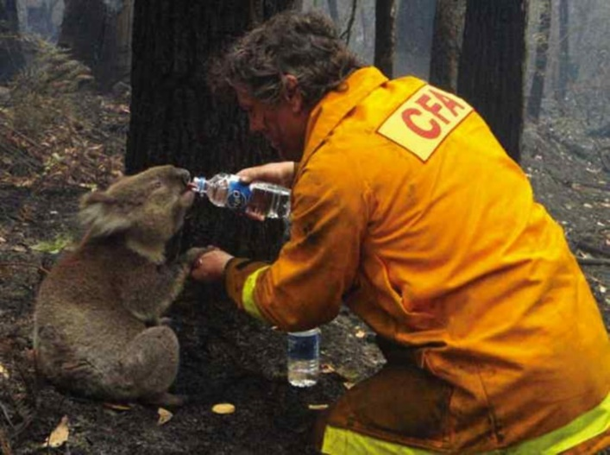

1. Display the map/plot of all the 3 training images here:

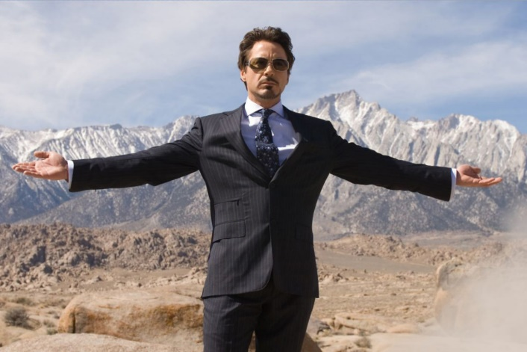

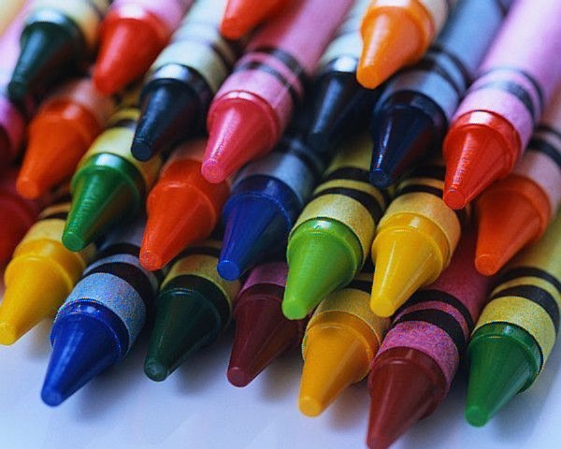

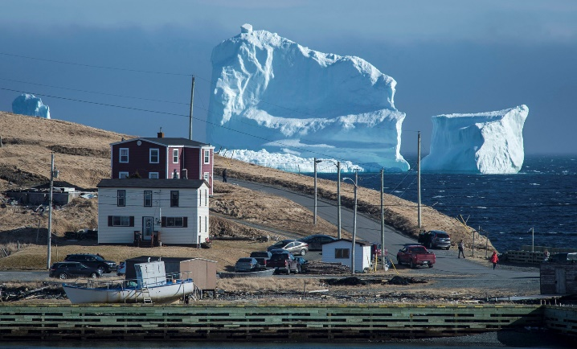

1. Post close-up of any artifacts you came across.

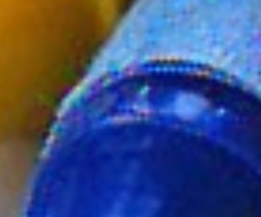

1. Average_per_pixel error and Max_pixel_error for each of 3 training images :

|  |  |  |
| --- | --- | --- |
| Image | Average_per_pixel_error | Max_pixel_error |
| Crayons | 143.5 | 53633 |
| Tony | 23.7 | 9640 |
| Iceberg | 105.2 | 30186 |

**Part-2 : Freeman Method**

1. Insert your Freeman Method test image(hope.jpg) here:

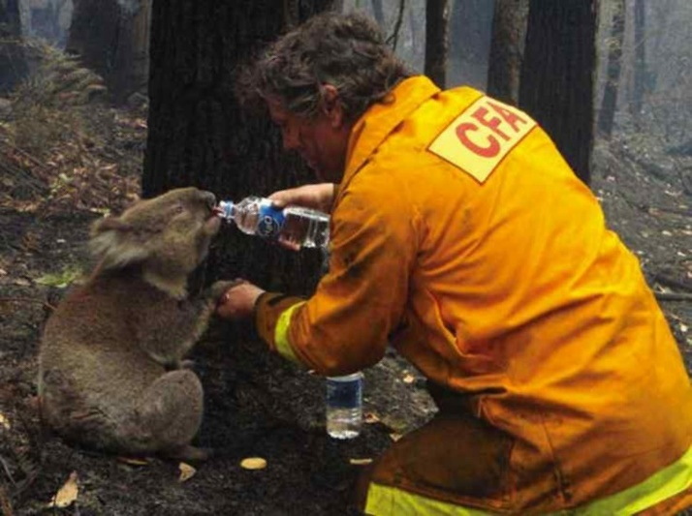

1. Display the map/plot of all the 3 training images here:

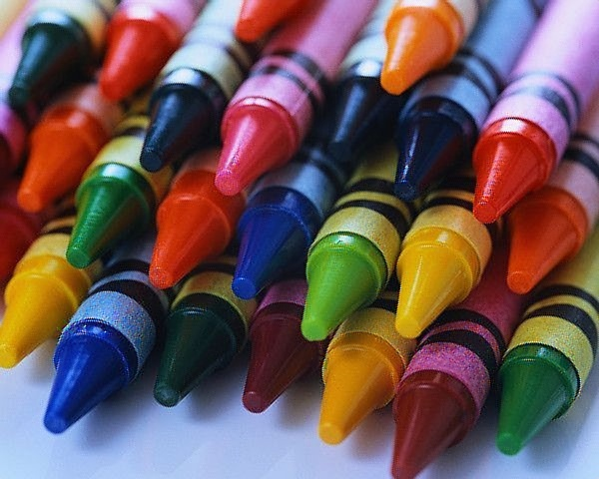

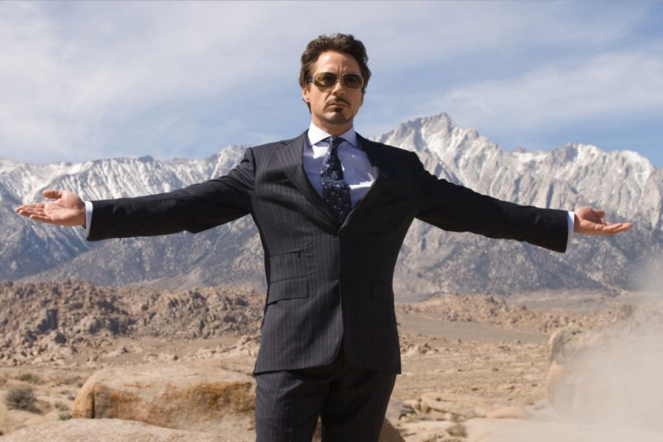

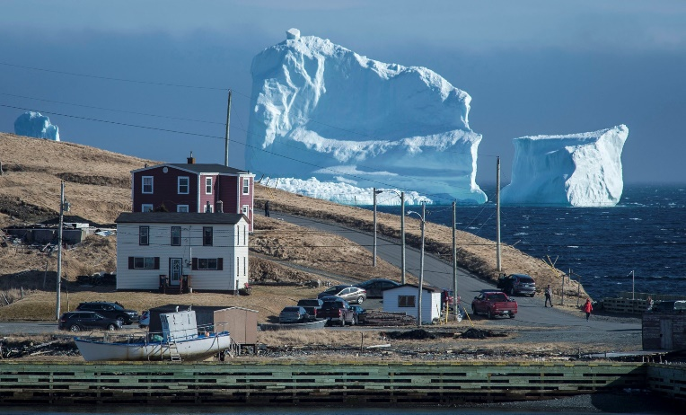

1. Post close-up of any artifacts you came across.

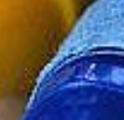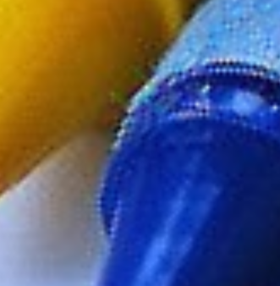

1. Average_per_pixel error and Max_pixel_error for each of 3 training images :

|  |  |  |
| --- | --- | --- |
| Image | Average_per_pixel_error | Max_pixel_error |
| Crayons | 100.5 | 48173 |
| Tony | 15.6 | 10753 |
| Iceberg | 66.5 | 34075 |

**Part-3 : Images of your choice**

1. Post 2 images your choice here and the corresponding error maps of your outputs with the Freeman method.

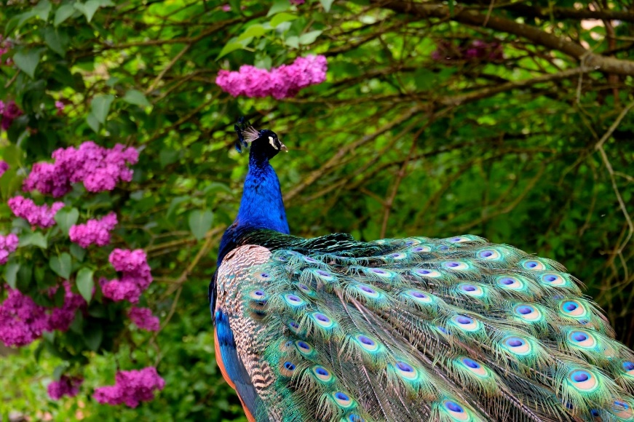

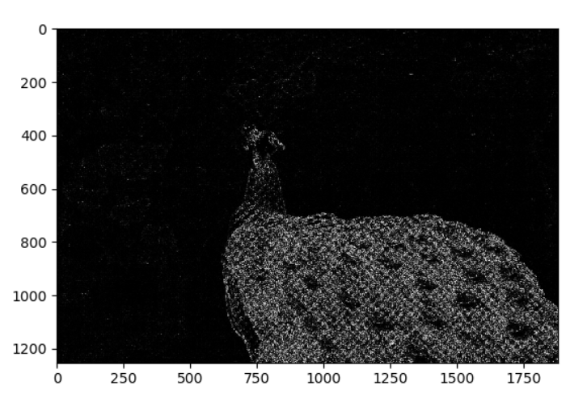

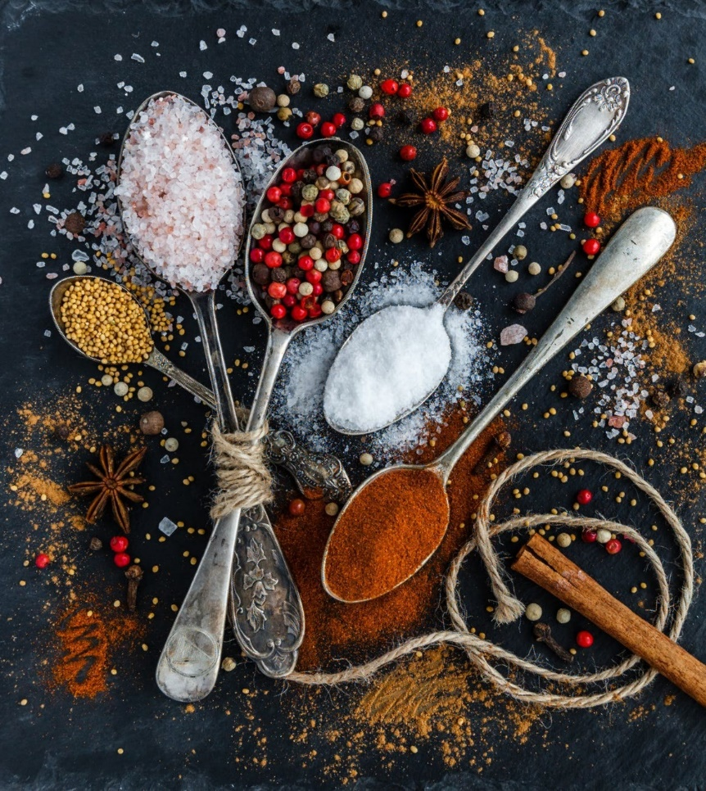

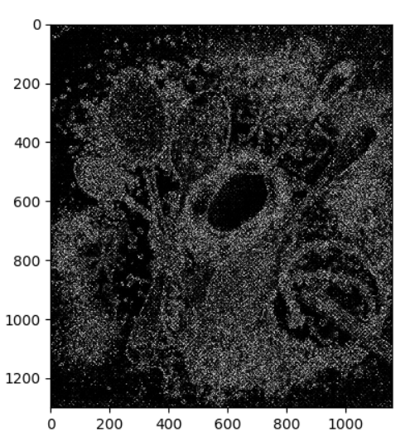

1. Any image that breaks the method and why do you think so?

Both images perform worse, especially in details.

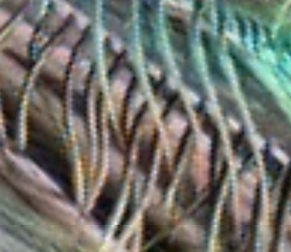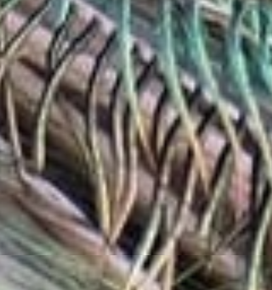

Left is the recover image, which has many obvious blue spots compared to the right image.

The reason is both these pictures has high contrast and more complex color variance. Apparently, just use the average of nearby pixels won’t fit very well.

This algorithm can perform better with images which have large continuous area in similar color. That is to say, low contrast images. Moreover, it should perform better if green is dominant in an image because it has as twice sample rate as the red and blue pixels.

**Part-4 : Bonus**

Post any extra credit details/images/references used here.

Instead use the algorithm described in the course website, which performs a medium average to all red and blue pixels, I tweak it a little bit.

Notice that we already have the real value of some pixels’ blue and red channels, we shouldn’t change them using medium average. So I keep these original values, mask the output of medium average to extract the other values, and sum them up to construct the final solution.

Experiment shows that this approach achieves better average error and maximum error.

